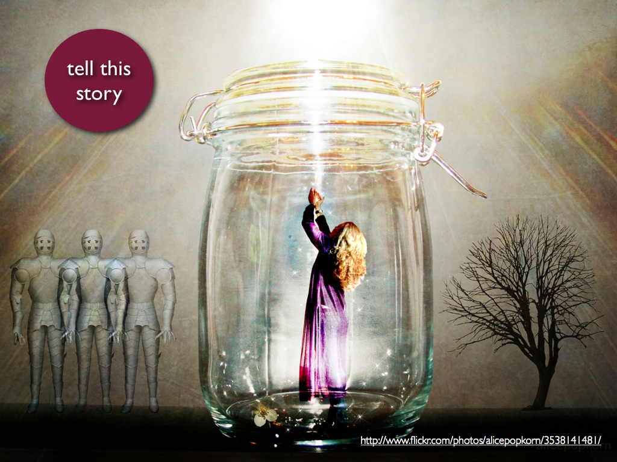1] (Remember, 150 words minimum.)

2] Describe what you want your life to look like 15 years from now.

3] Write about whatever you want or something about the book you

read today.